Cleftlands Not-Necessarily-a-Cookie Exchange
Figure 1 Sesame Wafers and Sesame Toffee: Angharad 2
Figure 2: Mask Lanyards, Nadyezhda 2
Figure 3: Mug cosies, Sara 2
Figure 4: Masks and goblet covers, Jaqueline 2
Figure 5: Goblet cover, Elizabella 3
Figure 6: Draco Invictus ornaments, Macro 3
Figure 7: Mini-journals and buttons, Eleanore von Tyne 3
Figure 8: Glass beads, Eikbrandr and Runa 3
Figure 9: Chocolate Chip Cookies, Constanza 4
Figure 11: Various cookies, Cyprian and Mor 4
Figure 10: Christmas earrings, Elizabethe 4
Figure 13: Decorative duct tapes, Jolicia 4
Figure 12: 9 Man Morris games, Madelaine 5
Figure 14: Christmas figure, and Book; Rose 5
Figure 15: Goblet and Chocolates, Ginger 5
Figure 16: Bowls, Clariscia 5
Figure 17: Wire wrapped spoons, Yang Bing-Xin 6
Figure 18: Wire wrapped spoon, Yang Bing-Ren 6
Figure 19: Toy plush knife, Yang Bing-Zhi 6
Figure 20: Fresh cookie dough, Zofia 6

Like a cookie exchange, you would bring one or more entries, equivalent in effort and/or expense to a dozen cookies (around $5). For every entry you bring, you can take one entry home. So, if you bring a dozen felt sewing kits, you could take home a dozen items from other people.
Entries could include:
A dozen cookies (because cookies are always good).
A small fruitcake.
A pair of beeswax candles.
An embroidered cup cover.
A stamped draw string bag.
A linen napkin.
Or anything else you can think of that people may appreciate.
Items should arrive by 7 pm to be set up in the viewing area: You can start choosing what you'll like to take home at 8 pm.

Figure 1 Sesame Wafers and Sesame Toffee: Angharad
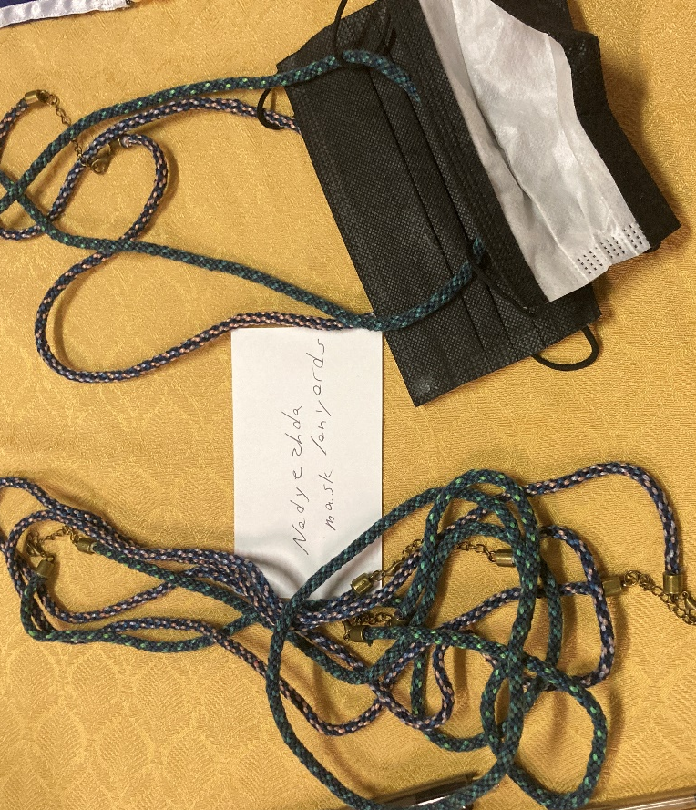
Figure 2: Mask Lanyards, Nadyezhda
Figure 3: Mug cosies, Sara
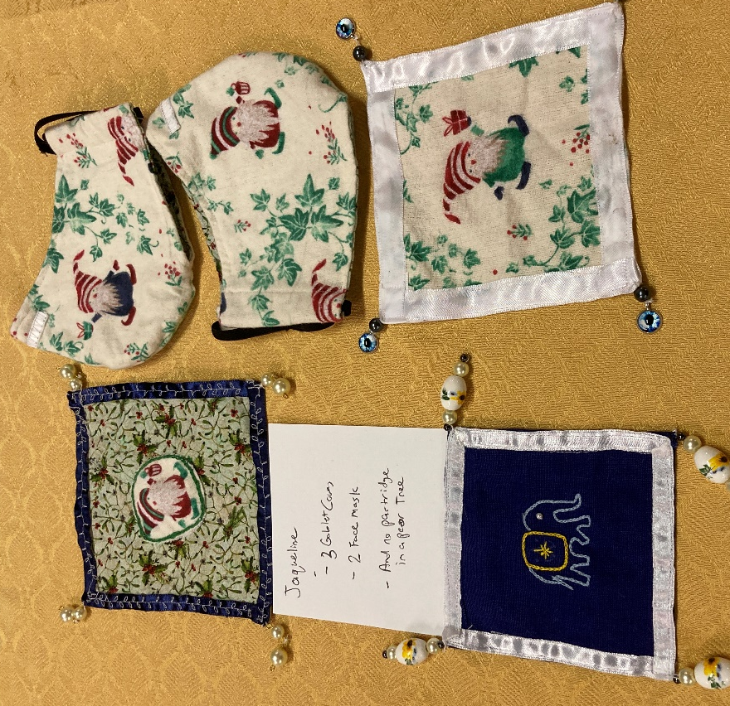
Figure 4: Masks and goblet covers, Jaqueline
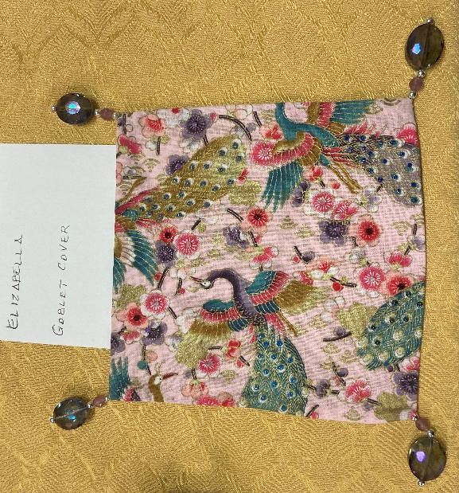
Figure 5: Goblet cover, Elizabella
Figure 6: Draco Invictus ornaments, Macro
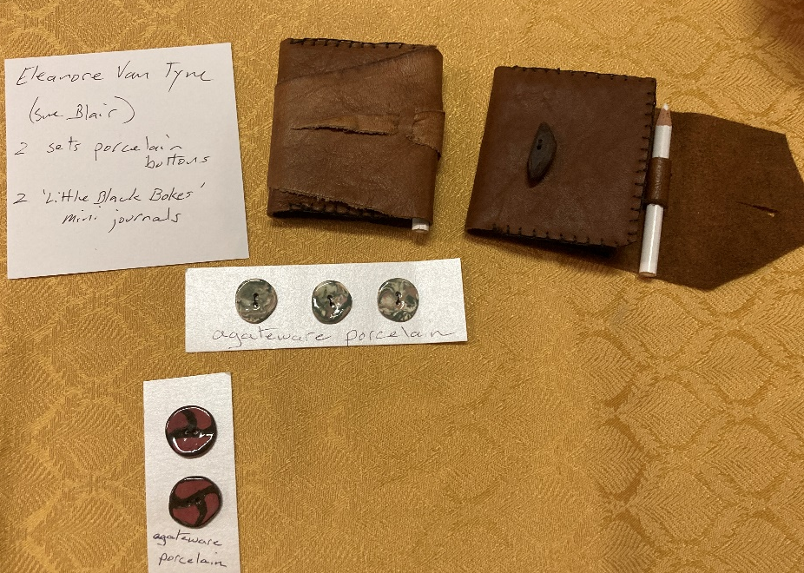
Figure 7: Mini-journals and buttons, Eleanore von Tyne
Figure 8: Glass beads, Eikbrandr and Runa
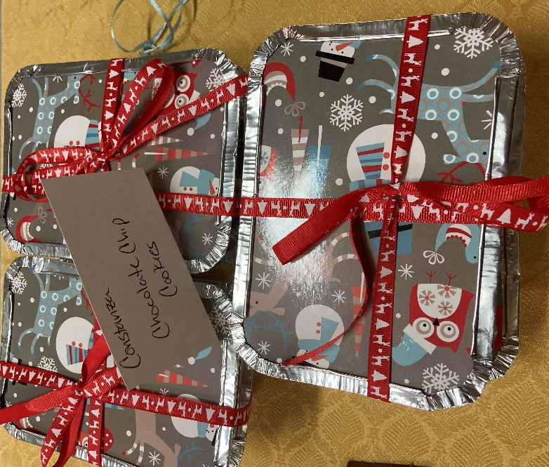
Figure 9: Chocolate Chip Cookies, Constanza
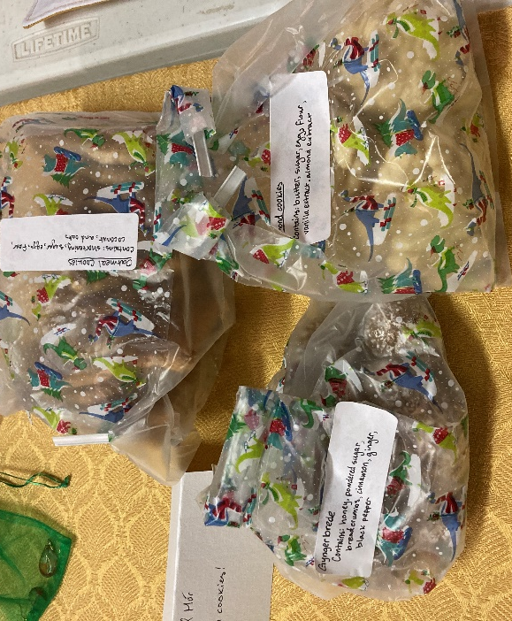
Figure 11: Various cookies, Cyprian and Mor

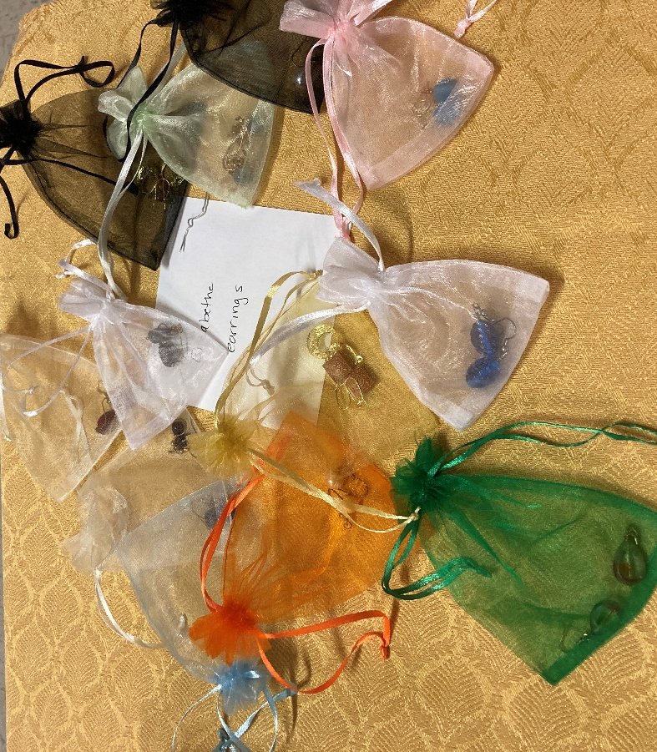
Figure 10: Christmas earrings, Elizabethe
Figure 13: Decorative duct tapes, Jolicia

Figure 12: 9 Man Morris games, Madelaine
Figure 14: Christmas figure, and Book; Rose
Figure 15: Goblet and Chocolates, Ginger

Figure 16: Bowls, Clariscia

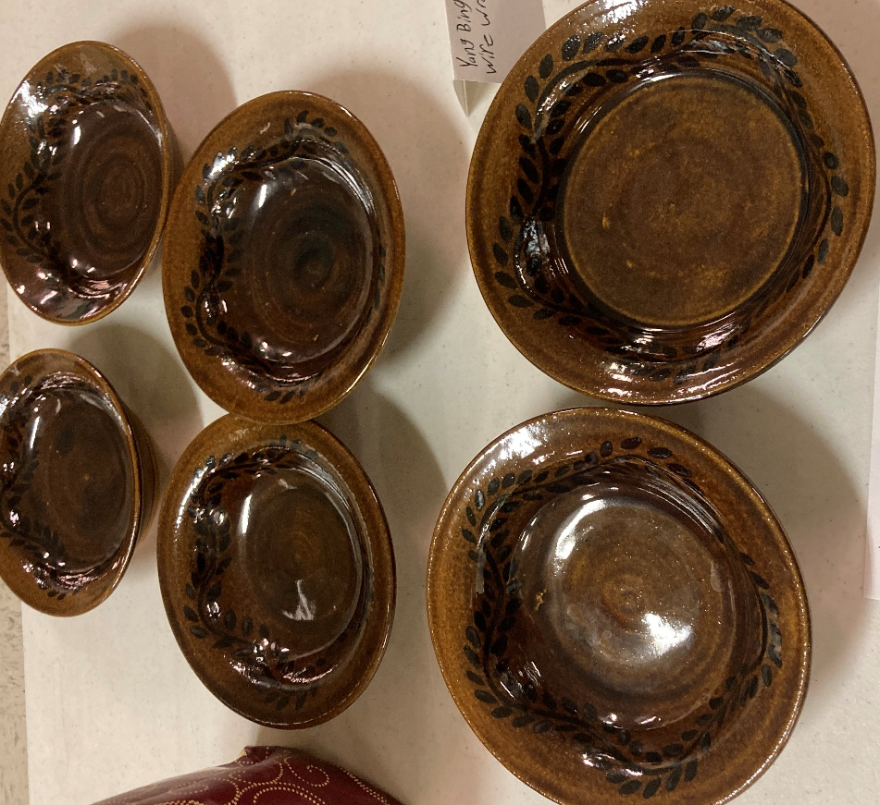
Figure 17: Wire wrapped spoons, Yang Bing-Xin
Figure 18: Wire wrapped spoon, Yang Bing-Ren
Figure 19: Toy plush knife, Yang Bing-Zhi
Figure 20: Fresh cookie dough, Zofia

